Term 2 – Second Half Maths Homework
Week 1- Measurement
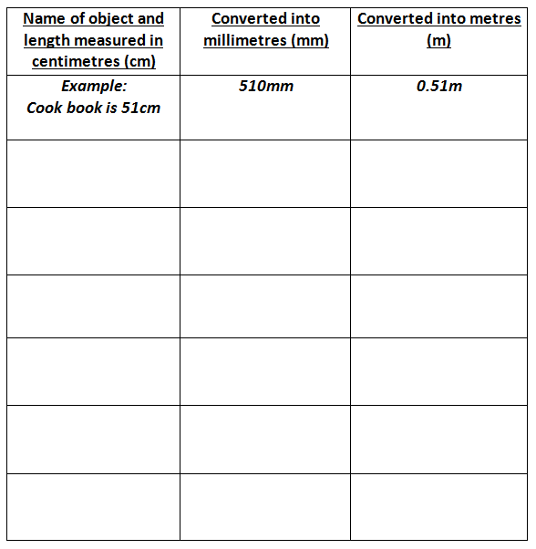
On Seesaw you will find the following table which you will complete.
At home, find and measure 6 objects in cm. Challenge yourself to find a variety of lengths. Then, convert the length into millimetres (mm) and metres (m) and record your answers.
Here are some hints and websites to help you convert your measurements:
1 cm=10mm
1cm=0.01m
Log into your MyMaths>Shape>Converting units>Metric conversion.
http://www.bbc.co.uk/bitesize/ks2/maths/shape_space/measures/read/2/
Week 2- Percentages
There is a sale on and there are now some reduced items! You need to work out the NEW PRICE!
1. 15% off £460
2. 24% off £525
3. 5% off £3600
4. 3% of £1900
On SeeSaw upload a video explaining your method and how you solved the questions.
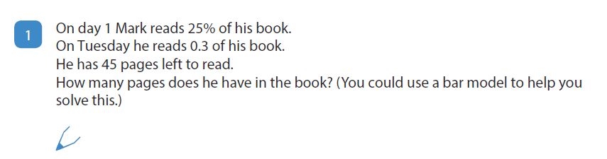
For those looking for some additional challenge, can you solve the problem below?!

Week 3- Algebra
- Find three different possible pairs of whole number values for a and b in the equations.
- Complete ‘Emergency Plumber’
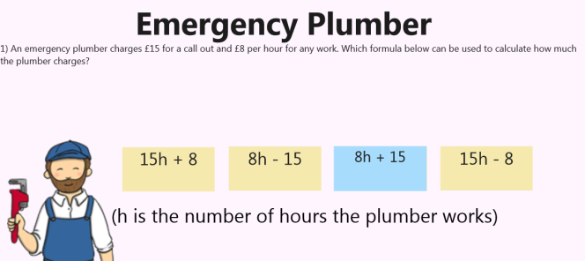
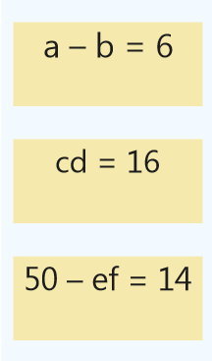

Add your answers to the comment section on SeeSaw.
Week 4- Volume
Complete the table and then make one for a peer to complete in class.
You can make a copy of this on SeeSaw to edit and add in the missing answers.
When you create your own you might want to create it on paper first then take a picture to upload it to SeeSaw.
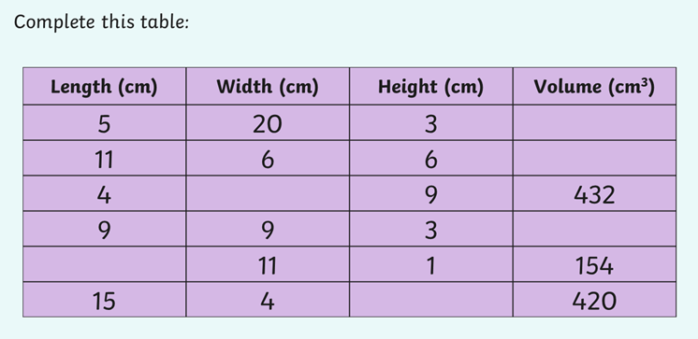
If you need some help to calculate the volume here is a link: http://www.ducksters.com/kidsmath/finding_the_volume_of_a_cube_or_box.php

Week 5- Fractions, Decimals and Percentages
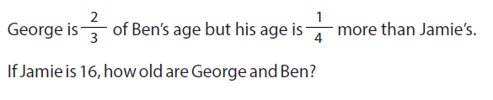
On SeeSaw explain your method.
